《数据仓库与数据挖掘》实验报告

姓名： | 朱志儒 |  | 学号： | SA20225085 | 日期： | 2020/11/23
上机题目： | Aprior算法和FP算法的实现
操作环境：
OS：Window 10
CPU：AMD Ryzen 5 3600X 6-Core Processor 4.25GHz
GPU：GeForce RTX 2070 super
一、基础知识：
Apriori算法：
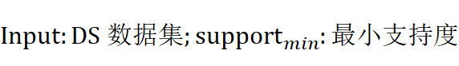
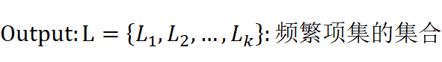
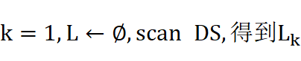
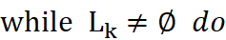
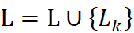
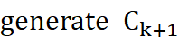 /* 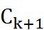是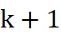项集，不一定是频繁的，等待“频繁”判定
的候选集*/
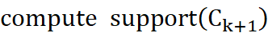 /*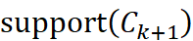表示中每个项集的支持度
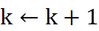
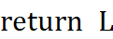
其中：
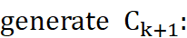
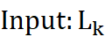每个项集有序的k-项集集合
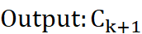候选“频繁”的(k+1)-项集集合
满足前k-1项相同的k-项集合并，产生(k+1)-项集
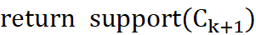
以及
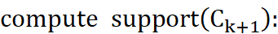
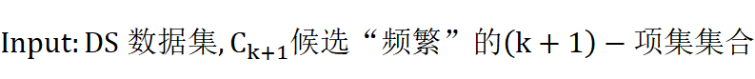
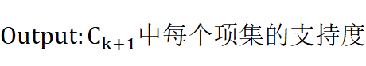
扫描一遍DS的元组，检查它包含的哪些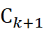中的项集，将被包含的项集的支持度+1
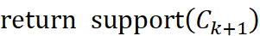

FP-growth算法：
输入：DS数据集，support_{min}最小支持度
输出：频繁模式的完全集
方法：
- 构造FP树：
- 扫描数据集DS一次，收集频繁项的集合F和它的支持度计数，对F按支持度计数降序排序，结果为频繁项列表L
- 创建FP树的根节点，以“null”标记它，对于DS中每个事务Trans，执行：
选择Trans中的频繁项，并按L中的次序排序，设Trans排序后的频繁项列表为[p|P]，其中p是第一个元素，而P是剩余元素的列表。调用insert_tree([p|P], T)。
该过程执行情况如下：
如果T有子女N使得N.item-name = p.item-name，则N的计数增加1；否则，创建一个新结点N，将其计数设置为1，链接到它的父结点T，并通过结点链结构将其链接到具有相同item-name的结点。如果P非空，则递归调用insert_tree(P, N)。
- FP树的挖掘通过调用FP_growth(FP_tree, null)实现：
Procedure FP_growth(Tree, α)
- If Tree包含单个路径P then
- for路径P中结点的每个组合（记作β）
- 产生模式β∪α，其支持度计数support_count等于β中结点的最小支持度
- else for Tree的头表中的每个a_{i}
- 产生一个模式β= a_{i}∪α，其支持度计数support_count = a_{i}.support_count
- 构造β的条件模式基，然后构造β的条件FP树Tree_{β}
- if Tree_{β} ≠ ∅ then
- 调用FP_growth(Tree_{β}, β)
二、实验过程：
根据Apriori算法和FP-growth算法的伪代码编写程序，读入data.txt数据集，找出频繁项集，改变support_{min}，查看频繁项集的变化，比较两个算法的性能。
三、结果分析：
当最小支持度为0.4时
Apriori算法： FP-growth算法：
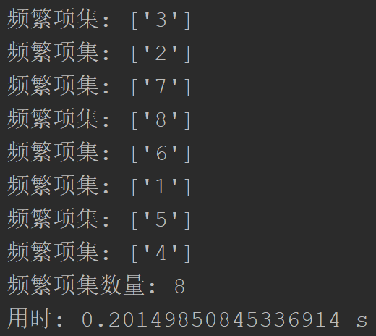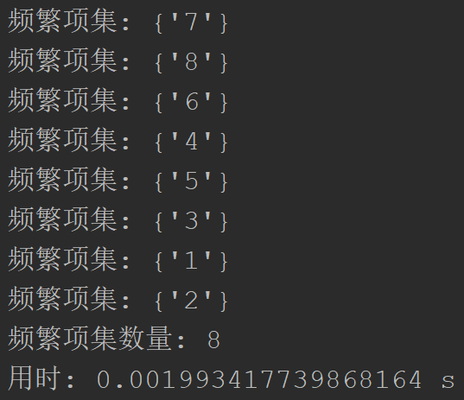
最小支持度为0.3时
Apriori算法： FP-growth算法：
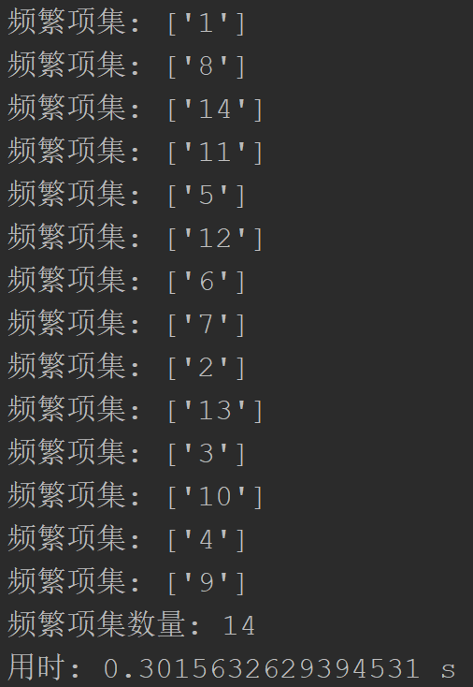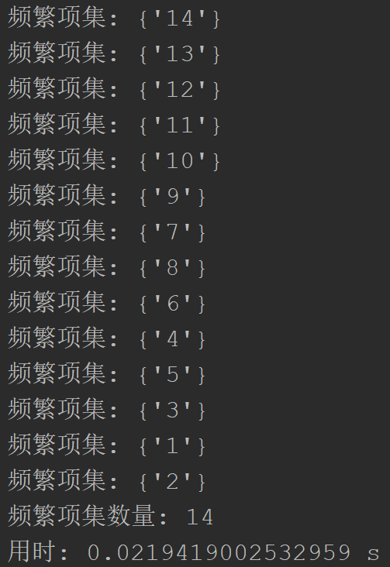
以上结果显示FP-growth算法的时间复杂度比Apriori算法的时间复杂度要低
附录 |  | 算法源代码（C/C++/JAVA描述）：  FP-growth算法：  - import time  - def load_data():  - data = []  - file = open("data.txt")  - lines = file.readlines()  - for line in lines:  - data.append([x for x in line.split()])  - data_dict = {}  - for line in data:  - data_dict[frozenset(line)] = 1  - return data_dict  - class Node:  - def __init__(self, value, count, parent):  - self.value = value  - self.count = count  - self.link = None  - self.parent = parent  - self.children = {}  - def inc(self, count):  - self.count += count  - def __lt__(self, other):  - return self.count < other.count  - def create_tree(data_dict, min_support):  - head_table = {}  - for line in data_dict:  - for item in line:  - head_table[item] = head_table.get(item, 0) + data_dict[line]  - for k in list(head_table.keys()):  - if head_table[k] / 2000.0 < min_support:  - head_table.pop(k)  - item_set = set(head_table.keys())  - if not item_set:  - return None, None  - for key in head_table.keys():  - head_table[key] = [head_table[key], None]  - tree = Node("null set", 1, None)  - for tran_set, count in data_dict.items():  - local = {}  - for item in tran_set:  - if item in item_set:  - local[item] = head_table[item][0]  - if len(local) > 0:  - order_items = [x[0] for x in sorted(local.items(), key=lambda p: p[1], reverse=True)]  - update_tree(order_items, tree, head_table, count)  - return tree, head_table  - def update_tree(items, tree, head_table, count):  - if items[0] in tree.children:  - tree.children[items[0]].inc(count)  - else:  - tree.children[items[0]] = Node(items[0], count, tree)  - if head_table[items[0]][1] == None:  - head_table[items[0]][1] = tree.children[items[0]]  - else:  - update_head(head_table[items[0]][1], tree.children[items[0]])  - if len(items) > 1:  - update_tree(items[1::], tree.children[items[0]], head_table, count)  - def update_head(test, target):  - while (test.link != None):  - test = test.link  - test.link = target  - def ascend_tree(leaf, prefix_path):  - if leaf.parent != None:  - prefix_path.append(leaf.value)  - ascend_tree(leaf.parent, prefix_path)  - def find_prefix_path(base, tree_node):  - cond_pats = {}  - while tree_node != None:  - prefix_path = []  - ascend_tree(tree_node, prefix_path)  - if len(prefix_path) > 1:  - cond_pats[frozenset(prefix_path[1:])] = tree_node.count  - tree_node = tree_node.link  - return cond_pats  - def mine_tree(tree, head_table, min_support, pre_fix, freq_item_list):  - big = [k for k, v in sorted(head_table.items(), key=lambda p: p[1][0])]  - for base in big:  - new_freq_set = pre_fix.copy()  - new_freq_set.add(base)  - freq_item_list.append(new_freq_set)  - cond_pat_base = find_prefix_path(base, head_table[base][1])  - cond_tree, head = create_tree(cond_pat_base, min_support)  - if head != None:  - mine_tree(cond_tree, head, min_support, new_freq_set, freq_item_list)  - if __name__ == "__main__":  - min_support = 0.03  - data_dict = load_data()  - fp_tree, head_table = create_tree(data_dict, min_support)  - freq_list = []  - start_time = time.time()  - mine_tree(fp_tree, head_table, min_support, set([]), freq_list)  - end_time = time.time()  - for item in freq_list:  - print("频繁项集:", item)  - print("用时:", end_time - start_time, 's')  Apriori算法：  - import copy  - import time  - def load_data():  - data = []  - file = open("data.txt")  - lines = file.readlines()  - for line in lines:  - data.append([x for x in line.split()])  - return data  - def satisfy_apriori(Ck_item, Lk_1):  - for item in Ck_item:  - sub_Ck = Ck_item - frozenset([item])  - if sub_Ck not in Lk_1:  - return False  - return True  - def generate_Ck(Lk_1, k):  - Ck = set()  - Lk_1_len = len(Lk_1)  - Lk_1_list = list(Lk_1)  - for i in range(Lk_1_len):  - for j in range(1, Lk_1_len):  - li = list(Lk_1_list[i])  - lj = list(Lk_1_list[j])  - li.sort()  - lj.sort()  - if li[0:k-2] == lj[0:k-2]:  - Ck_item = Lk_1_list[i] | Lk_1_list[j]  - if satisfy_apriori(Ck_item, Lk_1):  - Ck.add(Ck_item)  - return Ck  - def generate_Lk_from_Ck(data, Ck, min_support, support_dict):  - Lk = set()  - item_count_dict = {}  - for line in data:  - for item in Ck:  - if item.issubset(line):  - if item not in item_count_dict.keys():  - item_count_dict[item] = 1  - else:  - item_count_dict[item] += 1  - data_len = float(len(data))  - for item in item_count_dict.keys():  - if item_count_dict[item] / data_len >= min_support:  - Lk.add(item)  - support_dict[item] = item_count_dict[item] / data_len  - return Lk  - def generate_L_and_support_dict(data, min_support):  - support_dict = {}  - C1 = set()  - for line in data:  - for item in line:  - C1.add(frozenset([item]))  - Li = generate_Lk_from_Ck(data, C1, min_support, support_dict)  - Lk_1 = copy.deepcopy(Li)  - L = []  - k = 2  - while Li:  - L.append(Lk_1)  - Ci = generate_Ck(Lk_1, k)  - Li = generate_Lk_from_Ck(data, Ci, min_support, support_dict)  - Lk_1 = copy.deepcopy(Li)  - k += 1  - return L, support_dict  - if __name__ == "__main__":  - min_support = 0.03  - data = load_data()  - start_time = time.time()  - L, support_dict = generate_L_and_support_dict(data, min_support)  - end_time = time.time()  - for Li in L:  - for item in Li:  - print("频繁项集:", list(item), "支持度:", support_dict[item])  - print("用时:", end_time - start_time, 's')

